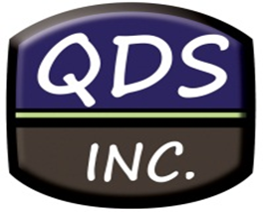

Quick Data Services, Incorporated

IMPORTANT NOTICE

The state of Utah is experiencing a problem with their search system where redacted items are not allowing the system to bring up any filings that may have been filed should they contain redacted information.

Therefore, we are unable to provide you with a completed report. The state is aware of this problem and is working diligently to repair the situation.

At this time, the state will be completing the search. Unfortunately, ‘listing only’ cannot be provided and a turn-around time cannot be given.

Quick Data Services, Incorporated is working with the state to provide these searches back to you as soon as possible. We will also keep you informed of any changes in this situation.

We appreciate your confidence in our team and close relationship with the state of Utah and their UCC team during this unfortunate situation.

Feel free to contact our office with any questions or to check status of your searches.

12/04/2017

